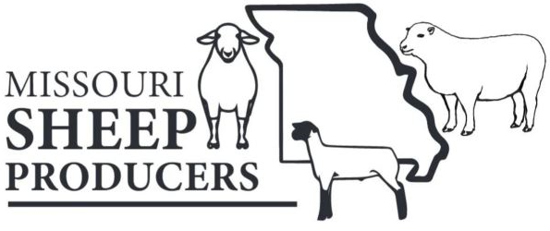
Application for
MISSOURI SHEEP SCHOLARSHIP
Sponsored by
Missouri Sheep Producers, Inc.

Deadline: May 15

Section 1:

Name
Parents/Guardian Name(s)
Permanent Address
City, State, Zip
Phone Local Newspaper
E-mail Address

High School
Name
Year Graduated Grade Point Average

College: ____ Applied ___Accepted ____Current Student
Name
Major Expected Graduation Date

Section 2:
Describe your future goals, including why you selected your major.

List up to 10 organizations, activities or awards relating to your involvement with the sheep industry.
Organization, Activity or Award | Number of Years | Leadership Roles

List up to 10 non-sheep related organizations, activities or awards in which you are involved.
Organization, Activity or Award | Number of Years | Leadership Roles

Briefly explain your financial need.

Section 3:

Essay: In 400 – 500 words describe your sheep experience and why you should receive a Missouri Sheep Producers, Inc. scholarship.

Complete applications must contain:

- current school transcript.

- current letter of recommendation, from someone who has known you for several years, stating why you should receive a Missouri Sheep Producers Scholarship.

- essay describing your sheep experience and why you should receive a Missouri Sheep Producers, Inc. scholarship.

- signed application

The Scholarship Committee may not consider incomplete applications.

Send applications to:
Christy Green
10220 CR 5120
Rolla, MO 65401
mosheepproducers@gmail.com

Applications postmarked after May 15 will not be considered.

Applicant’s Signature

Date
Guidelines for
MISSOURI SHEEP SCHOLARSHIP

- Eligible applicants are college students or high school seniors who are residents of Missouri and attending a college or university (in-state or out-of-state) of their choice or out-of-state students attending a Missouri college or university.

- Applicant must be or have been a 4-H or FFA member with a sheep project, or have been involved with the sheep industry for at least three years. A letter of recommendation from the project leader or chapter advisor should be included with the application.

- The Missouri Sheep Producers will award four (4) $500 scholarships.

- Applicants may only receive the Missouri Sheep Producers Scholarship one time.

- Applicants who are not awarded a scholarship are encouraged reapply.

- Undergraduate and graduate level students are eligible to apply.

- The Scholarship Committee will judge the applications. Scholarship recipients will be notified by mail and their checks will be presented at the Missouri State Fair.

- Complete applications must be postmarked by the deadline or they will not be reviewed.

